Okay. So now that we are a little bit more familiar with the interface and navigation, we can move on to manipulating objects within the 3D viewport. In this lesson, we're going to start learning some of the keyboard shortcuts that we are going to be using in Blender. So Teacher have downloaded an app that will display my keystrokes down here in the bottom left corner. We are going to be using a lot of keyboard shortcuts going forward.

So we have our starter cube here as marked below, and this is what is known as a mesh object.

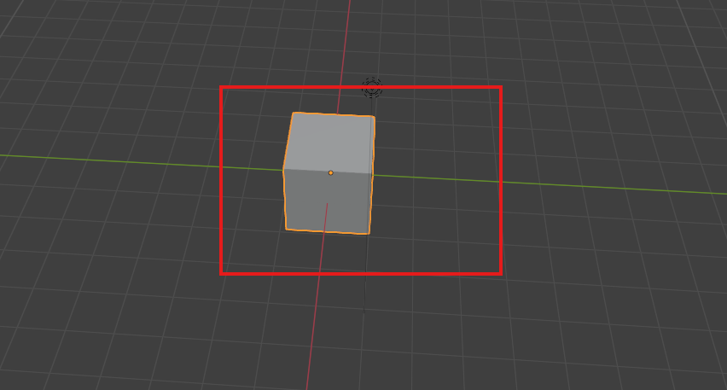

A mesh object is basically any 3D object that the computer renders using points in space called vertices to draw lines between called edges, which subsequently have faces drawn between them and are rendered opaque. Teacher will talk a bit more about vertices, edges and faces when we get into mesh editing. So in layman's terms, a mesh is basically any solid object that compromises the stuff in our 3D space. Everything that we model in this course is going to be a mesh object.

It's anything that isn't something like a camera or a light or a (non solid data type)(who knows). Mesh is often referred to as geometry. So you may hear me use those terms interchangeably. We're going to start by transforming the default cube. Transforming in the world of 3D graphics is just a way of collectively referring to the location, rotation and scale of an object in 3D space.

Press N on your keyboard to bring up the sidebar under item and then to transform panel as marked below.

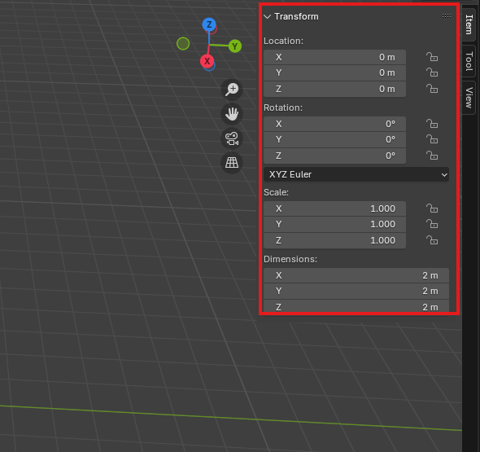

You'll see that this panel contains all those pieces of information of location, rotation and scale, as well as the dimensions of this object in real world space and real world units, which is driven by this scale value(property of transform) here.(Maybe the dimension is telling that whatever how much you scale the object the dimension will tell how much will the object will take space in real world in the current scaling in a particular parallel to axis.)

So we want to move this mesh around in our scene. All we have to do is select the cube by left clicking on it. The selection will be represented by this orange highlight around the edge here.as shown below

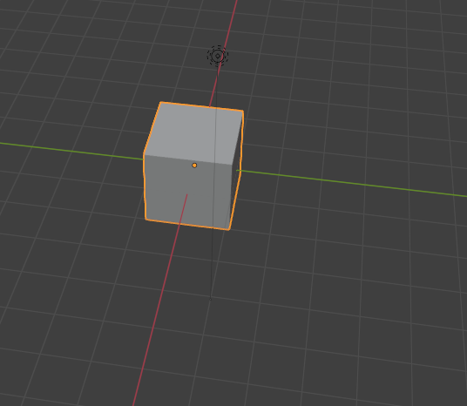

So once it's selected press **G** as in grab. And now you can see that when I move my mouse around, the cube moves with it and pointer shape changes to something which I could not record by snip. Very cool to drop the cube into a new location. Simply left click again when it's in the position that you want it. To drop the selection and cancel the operation while you're moving around. After pressing G **right click** and it will snap back to its original position to rotate. This right click way can be used in many circumstance where we want to undo something even in any software other than blender.(who knows)

3:00

Now to rotate an object then left click on the object that you want to rotate then hit R as in rotate and move the mouse to manipulate the object as shown below and then

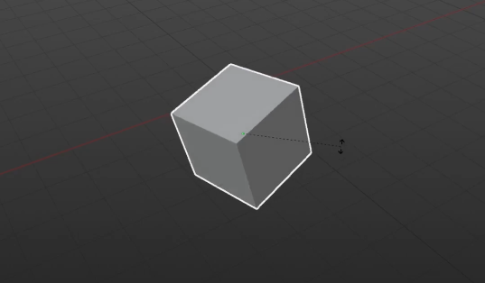

left click again to confirm the rotation of the object to scale an object selected by left clicking hit s as in scale and move the cursor away from the model to scale up as shown below

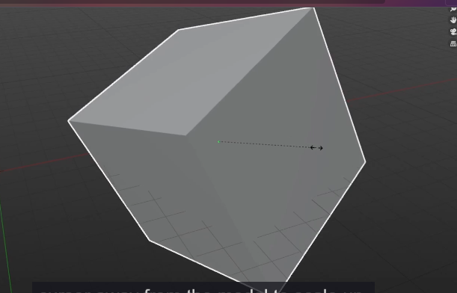

Now move across it towards the object to scale down. As shown below

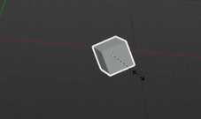

Once again, left click to confirm the new scale.

Teacher would just like to make a couple of quick additional points about scale.

In the world of 3D graphics, the size of something it's referred to as its scale and scale works as a decimal system.

When you add a new primitive object.

Now when you see in the pop that is visible by pressing N

Now we can see the selected object scale in this case cube

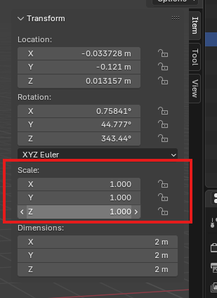

It will have a scale of one in all directions in X and Y and Z.

__________________________________________________________________________________

**Note:-**

To create a primitive mesh object press **Shift + a** on any empty space in 3d viewport

And then a submenu will be opened click on mesh and then in next submenu choose any predefined

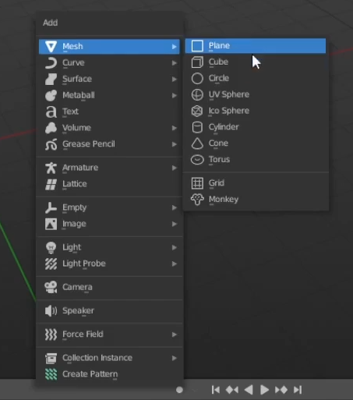

Mesh object you want

The default cube primitive is added to the dimension with a scale of one, but dimensions of two metres but dimension of two metres by two metres by two metres, meaning it is two metres long and the x direction two metres long in the y direction and two metres long in the z direction.(maybe if they were in the real world )

Now this object is of scale of 1 for this cube object so we make the scale 2 in all direction in n popup

We change scale in N popup in x direction Now it will look like below

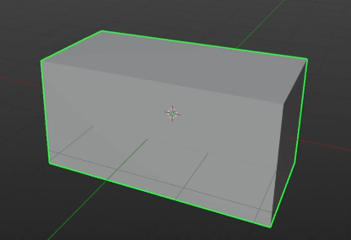

We change scale in N popup in y direction Now it will look like below

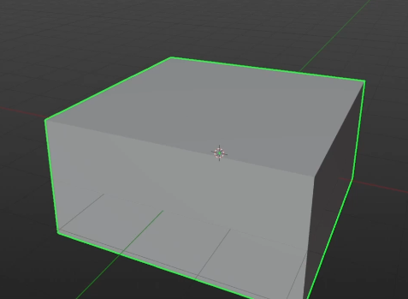

We change scale in N popup in z direction Now it will look like below

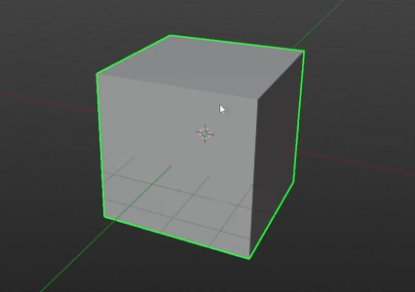

We now have a cube that is twice the size and we can see that reflected here in the dimensions where it says four metre by four metre by four metre because four is twice of two as marked below

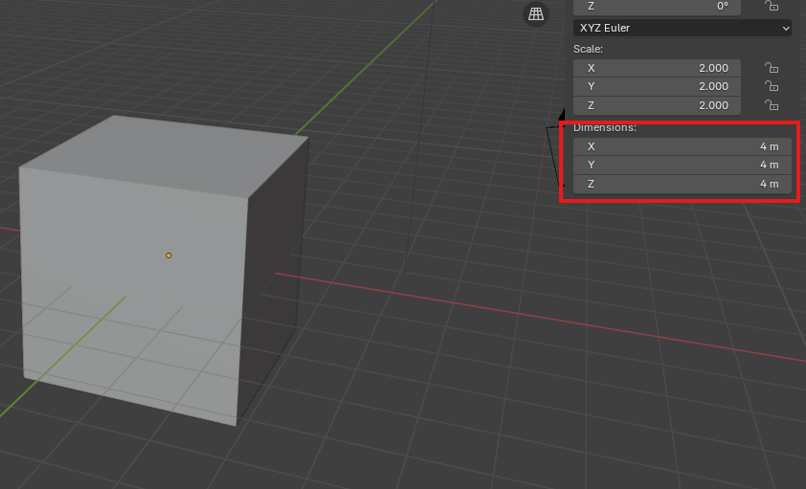

because four is twice of two.

Giving the original object of scale of 0.5

__________________________________________________________________________________

**Note:-**

If we press s by left click then it will scale but you can also give it some value while doing so and whatever numerical value you will type that will be the nx of selected object in all axis

For example you press 2 then the result and object will be 2x

Now if we scale our cube object of scale 1 by s method then while scaling by this we type 0.5 then it will look like below

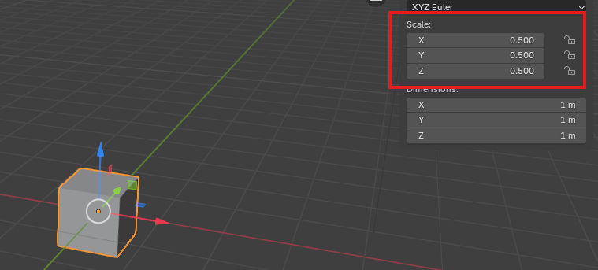

You can see the scale as marked above and you can see it is 0.5 in all axis

And also you can see the dimension of one metre by one metre below the marked

And as a side note, Teacher have units for blender set to metres. If it's not set two metres for you, don't worry. At this point it really doesn't matter what units you're using here.

But if you want it to be in other just for ease of following along, you can set the world units by coming into the properties in the right hand side go to the scene properties as marked below , Go under units. And you can set oy here just make sure that the unit system is metric. The unit scale is one and the length is in meters or you can set it to other units like centimeters, kilometers and anything you want as shown below when you open the length submenu

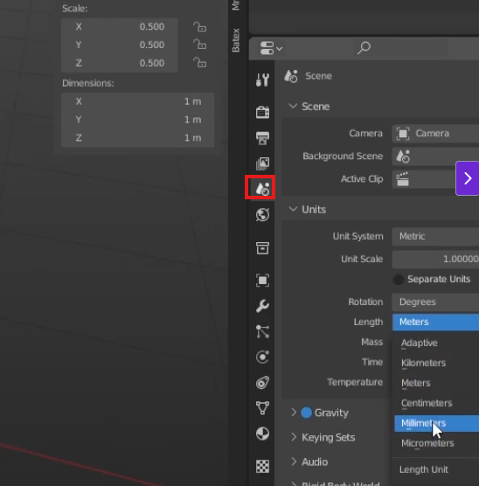

All this means is that now within the 3D viewport, one of these grid lines Is equal to one square meter. All this means is that now within the 3D viewport, one of these grid lines is equal to one square meter(I don’t think it does work like that anymore and I think it just effect the unit of dimension ( who knows )). You can see below image to see how a cube of dimension of 1 in all axis fit the section grid so perfectly as shown below

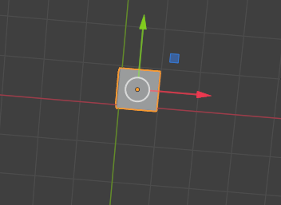

6:20

One metre in x (red) axis and one metre in y(green) axis. This is more important if you're going to be exporting your models into another program. But for now, just know that if you need to change the units in your scene, you can do so here. Okay, so getting back to transforming objects, all these keys (I think s , r or g )on their own will perform the operation in all three directions.

So if you wanted to scale an object uniformly, you can press x. And see that it's getting larger, but it is not changing shape at all. It's still a cube because we have scaled it uniformly in every direction. But going forward, we're definitely going to need more control than that.

We will often want to move or rotate or scale in only one direction at a time. We can do this by pairing the grab, move and rotate keys with either the X, Y or z key on the keyboard and depending on the axis

Remember that in blender the x direction is for left and right. The Y is for forward and back, and the Z direction is for up and down. So for instance, if I wanted to move this cube a little to the left, I would select it, press G for grab, and then press X on the keyboard.

And now you move it then it will move left and right as shown below

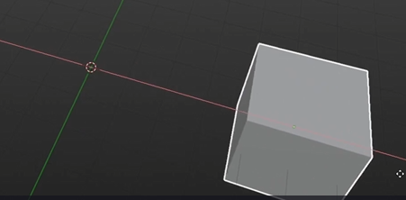

If I wanted to rotate it around a single axis, I would hit R for rotate and then Z for the Z axis. Now you can rotate it around z axis as shown below

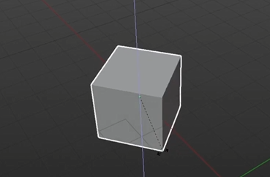

Right click to go back to cube position before the rotation And now we can see it is moving around. Z Axis, which is drawn by that blue line that appears when you lock the axis.

If I wanted to make this cube into a rectangle, I could scale it along a single axis so I could select the cube by left clicking press s for scale and y for the axis. I'd like to scale it along and we can pull it along in alongside it along the y axis as shown below

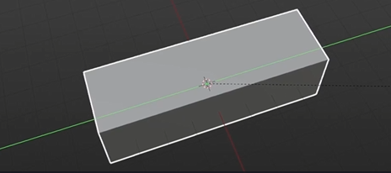

until it's more of a rectangle. You can also scale along two axes at once and lock the value of the third axis.

So let's say I wanted to push this box back into the right( right of y axis ), but I didn't want it to lift off the ground at all. The ground being these grid lines here. All I would have to do is with the box selected press G for grab, hold shift and then press Z to lock the Z axis.

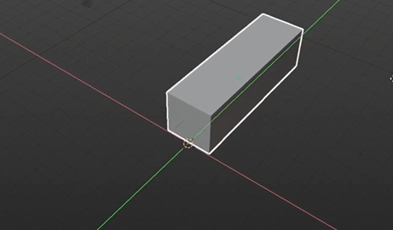

Now you can see its is being moved along x and y plane and leaving Z as shown above

And now we can move this along the floor here, move it back in to the right. And we can see we come into a more front view that it has not moved up or down at all. As shown below.

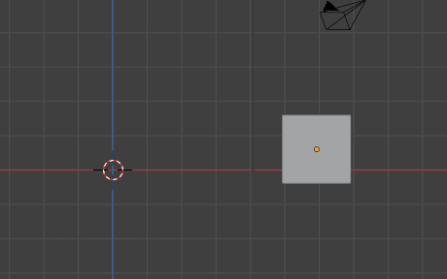

So whichever transform operation you want to use plus shift and then the Axis key will lock the values in that direction. So if I wanted to make this box thinner, but not make it any shorter along the Y, I would press s for scale, hold shift, and then press y to lock the y axis. And you'll see the other axes which it is manipulating are being drawn on the screen as shown below

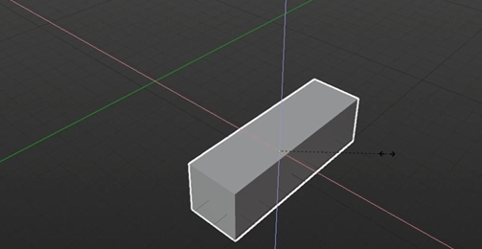

You'll see that the box gets thinner but doesn't lose any of the length along the y axis. As shown below

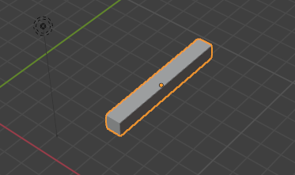

Additionally, if you need to be really precise about how much you move, something like say you wanted to rotate an object exactly 45 degrees.

You can change these properties manually in the sidebar (the we get by N button) .You know, you can type 45 into the X in the rotate section as marked below of the transform panel

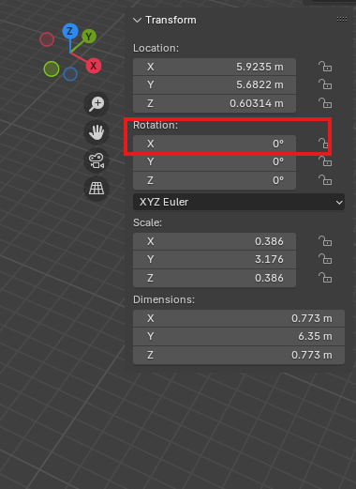

and it would rotate it 45 degrees as shown below

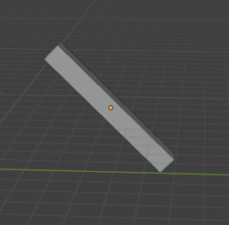

type 90 to rotate 90 in z axis as shown below

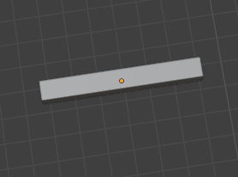

Or it was much quicker to do so with this keyboard shortcuts which we can do. By pressing first the transform key that we wish let's say are for rotate and then the axis. We wish to rotate it along Z for the Z axis and then simply before we left clicking confirm we just want to type 45. Now this will rotate it exactly 45 degrees from where it was(means if you are in 90 degree then after this you will be 135 degree). As shown below

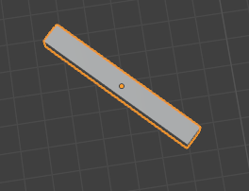

Now you can see in sidebar (that we get by N) that in rotation for z 45 is written as shown below

11:25

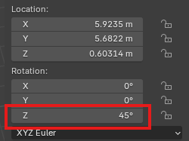

Now when you are typing the number you cannot rotate it more by mouse same for another operation.

Now if you want to rotate in another way then you could do so by just reversing the direction. Just type the negative number you want to rotate in reverse while rotating and locking an axis.

If we want to rotate an object on an axis in 45 degree reverse then select and then press r and lock z axis and then type -45

**Discovery:-**

If we perform some transformation (except scale)on an object then they will be occurred according to the plane parallel to hoe we are viewing it in 3d viewport

when you're working on a 3D grid or even a 2D grid. The sign in front of the number will inform the directionality of the MASH(who knows) or the operation.

for example, start with a new cube here Right now our location, rotation is zero.(in n popup ) But if we pressed G for grab, we wanted to move it along the x axis.

We could do so manually saying two and it would move it two units two meters along the x. as shoen below

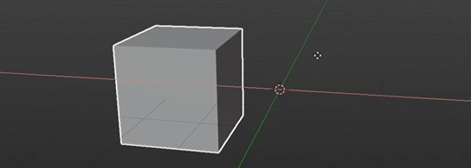

In location (N popup )you can see the location along is 2 as shown below

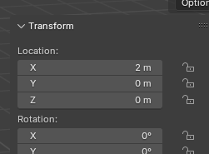

If we wanted to move it the other way, we could do the same thing. G x negative two. We'll move it in the negative direction. We do the reverse with value 2(that is -2) ()after moving the cube again tat the center as position and after this cube look like below

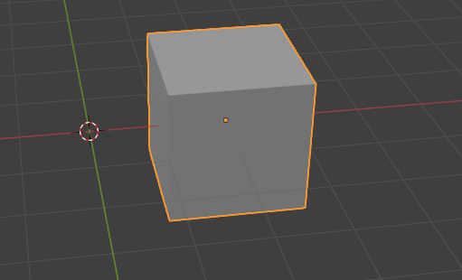

Remember that this point here at the center of the world where all three axes intersect(as marked below) represents a location of zero.

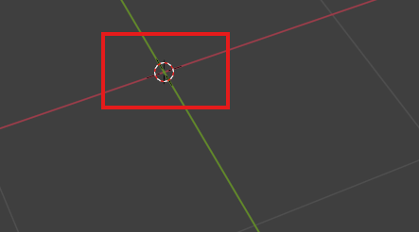

So this location, as driven by this green dot(orange in modern blender)( as marked below )(I think it tells the effective position of that Mesh object according to the 3d Space from the center of the world and it present in every object), which we'll talk about more in a minute, is at a location of exactly negative two meters from this point.

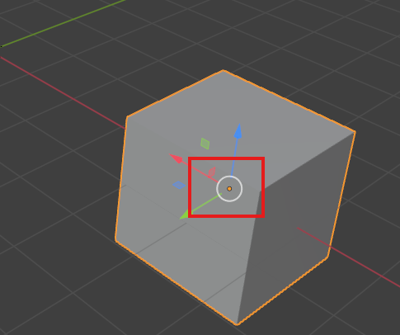

Now Blender does have a gizmo and I believe it is even on by default.

**Gizmo matlab ek chhoti si cheez (tool ya gadget) jo kuch specific kaam ke liye bani hoti hai, lekin kabhi-kabhi uska naam hume yaad nahi hota ya complicated hota hai.**

But if it is not on for you, all you have to do is come up here to the top right hand corner of the Screen(as marked below) and make sure this button that says Show Gizmo(in tooltip) is on.

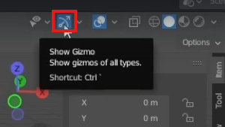

By gizmo we mean all the shown below

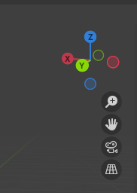 and also the handles of move, scale and rotate (when the pointer is select box in tool box as marked below)

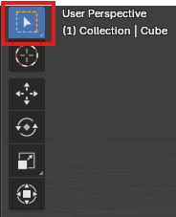

Now, if show gizmo option is enabled and you're still not seeing a gizmo on your object, just drop down this arrow as marked below

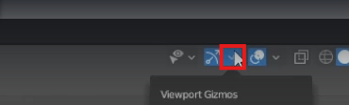

Now a submenu will be opened as shown below and you can check the move, scale and Rotate checkbox ( as marked below ) to add their gizmos when you select an object by select box If you check them all then all of them will be shown which will be good for us as we don’t need to use Rotate, move and scale tool separately you can so all of them by select box also

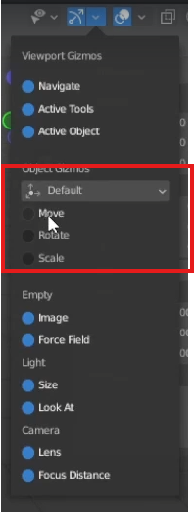

Suppose if I check move then when I select my cube then move gizmo will be shown as shown below

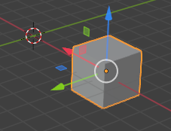

So This will make the gizmo appear on your object.

So a gizmo is just this little arrow manipulator that allows you to transform an object by clicking and dragging these arrows rather than learning The keyboard shortcuts.

Teacher personally think that it is faster to use the hotkeys, but that being said, the gizmo is used in a lot of other 3D applications. So if you were familiar with something like Unity, this might be familiar to you already.

If I check all of them it will look like below

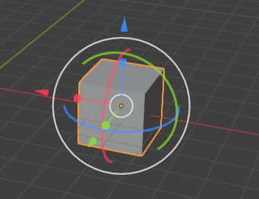

Now you can do all of the operations like Rotate, Scale and move. The arrows, of course, being for moving the object, the circles being for rotating and the squares for scaling.

Now we slightly rotate our object as shown below

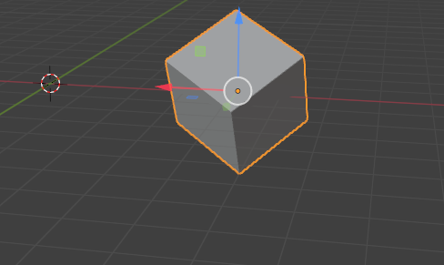

Now, you may notice that even though I have this cube rotated at an angle relative to these axis lines

15:00

the arrows on the gizmo are still matching the direction of our world axis as shown below This is what is called global space, and it refers to the orientation of this this entire empty scene(or scene). The rotation of the scene cannot be changed because it is the basis for which we describe how objects within it are rotated(I don’t know). Practically, practically, if we have the cube as shown below rotated relative to our world space

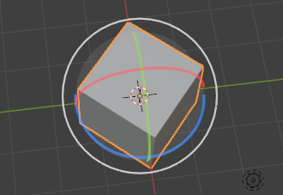

something like that. If our transform orientation, our gizmo is in global space, that means it would perform these transform operations according to the direction of the world. So if I wanted to make this cube into a rectangle now with this rotation applied. We would hit s and then y same way and when now we will scale it along y axis then its side will shrinked like below

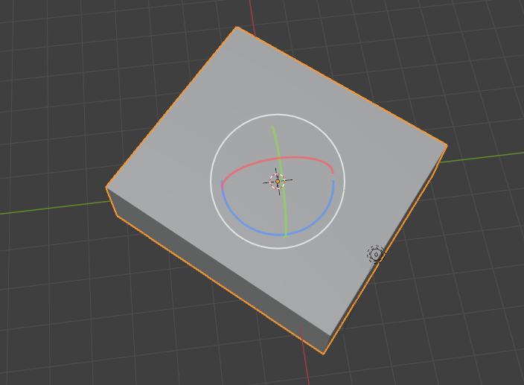

This is because it is scaling along y green axis due to which it was scaled along the vertical edges (similar to when you stretch something along its edges diagonally ). Now it becomes very distorted Now, we can definitely still make this a rectangle without changing the rotation back to match the world.All we have to do is set our transform orientation into what is called local space. Local space is basically using the rotation of the object relative to that of the world space to define the direction of this x, y or Z axis.



So when an object is rotated above like this, if you go up to this top bar as marked below

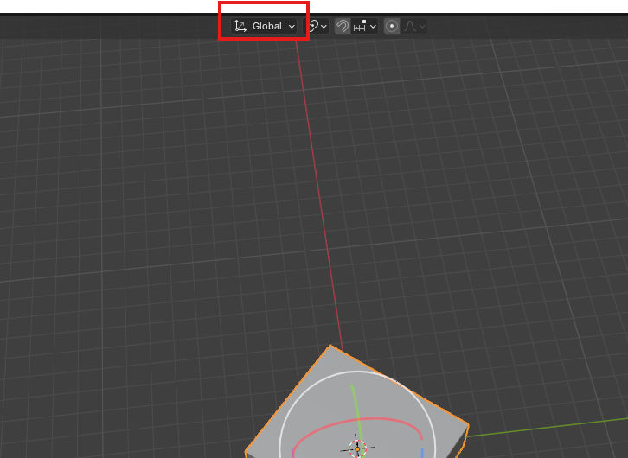

up here where it says Global as marked above. Now in submenu you can change the transform orientation to local space as highlighted below.

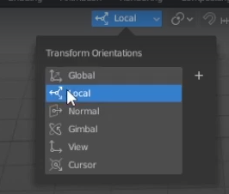

Now you see the gizmo is rotated according to the orientation of the cube as shown below

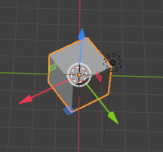

You'll now see that the gizmo arrows have snapped in according to the rotation of the cube.

So now if we scale along the y axis, it's going to scale properly as shown below because it is using the rotation of the cube

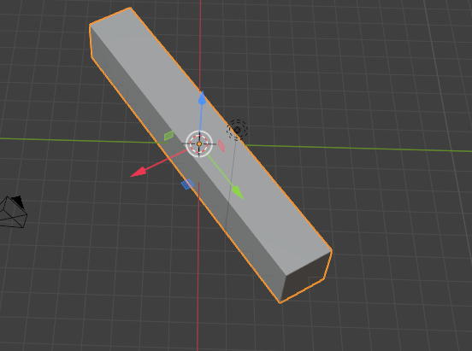

Now the **y** axis is rotated . However, a much quicker way to switch between local and global space without having to change it from menu. If you want to perform any transform operation in local space, all you have to do is hit the transform hotkey for the operation you want to perform and then double press the axis button.

Example is come back to the global and we will do the operation of scale in terms of local y

When **y** is pressed once

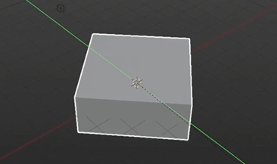

And when **y** is pressed twice

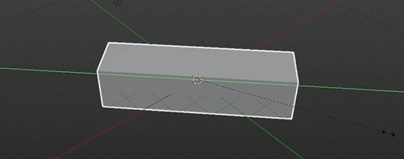

click to confirm. The shortcut works for all transform operations, including move and rotate.

**Discovery:-**

If any of the mesh object local axis is aligned with its corresponding global axis then you cannot perform local operation because at that time local operation on that axis will be same to its global axis operation.

18:20

Same thing for rotation.

Our cube is like below

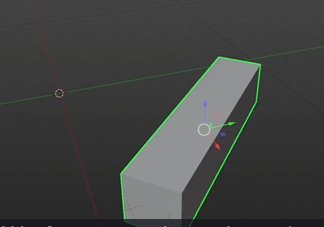

To rotate it along its local axes.I would hit r four rotate to give me the rotation tool, let's say X for the x axis globally

Now it will look like below

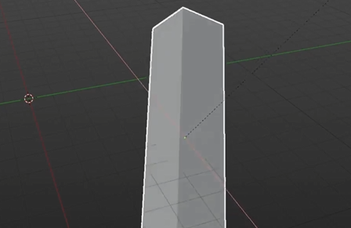

, and then x again to change that to the local axis. As shown below

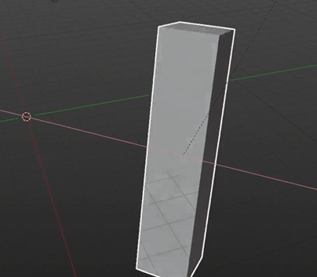

Any of these transfer operations you performed is stored in memory and can be undone using **ctrl + z**. I believe Blender saves something around 50 steps in memory and I believe you can configure that in the preferences as well. But 50 is plenty .You can redo any of the undone operations by pressing **ctrl**(maybe right because it is happening in my computer ) and then **shift** and then **Z** and it will redo the operation.

So let's say you transform it by using these transform as shown below

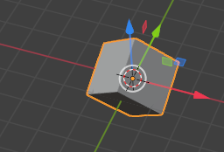

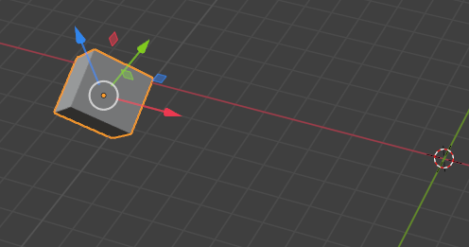

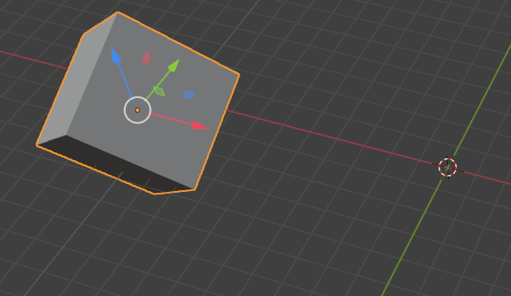

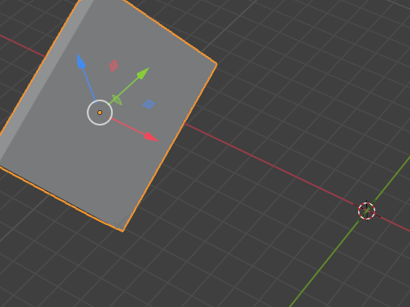

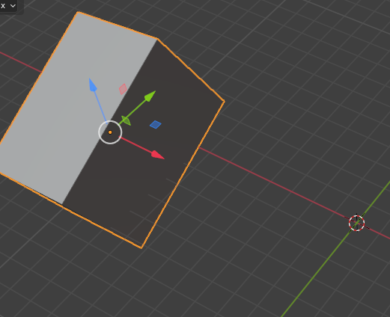

. However you wish, and then you decide that you really need it to be back at the center of the world. But maybe you've done some other operations and you can't undo back through it(who knows).

You can quickly clear the transforms by using the alt key combined with the transform operation key.(undo all the particular transformation like move, rotation and scale ). So holding **alt** and pressing **g** will clear the location that is make the values 0 in location in N popup as shown below.

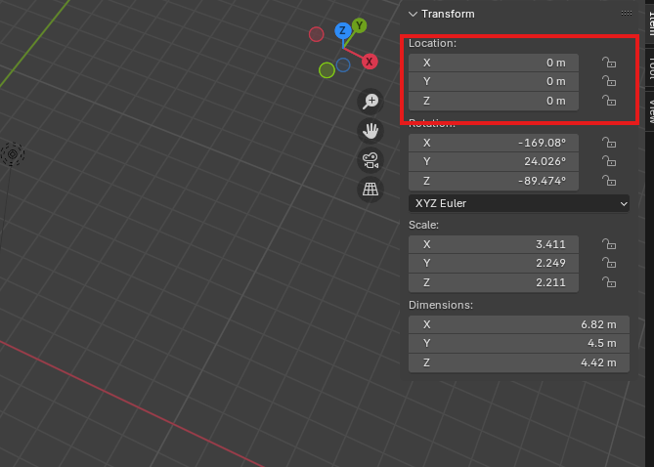

Now mesh is snapped mesh back. So its center point is at 000 on the grid as shown below

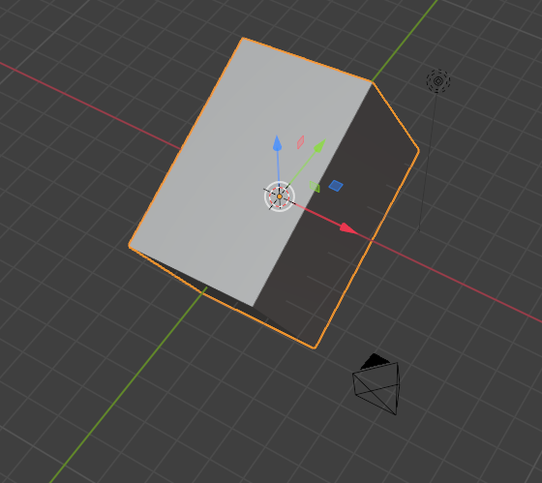

You can also do this with **alt r** for rotation.

This value has now been reset to zero in rotation section as marked below of **N** popup as shown below

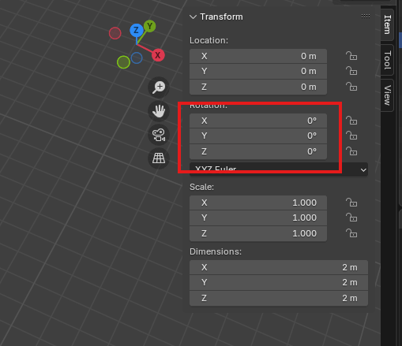

Now our object will look like below

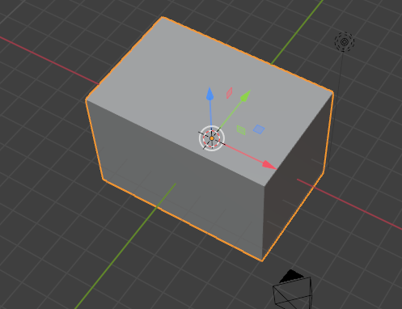

and **alt s** will reset the scale section as marked below in the **N** popup as shown below

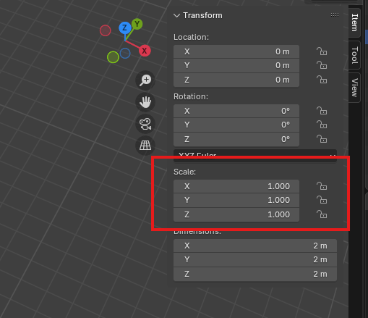

Now our object will look like below

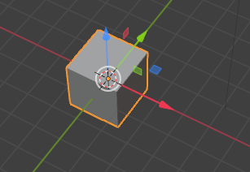

20:10

So now we have returned to our default cube with no transforms applied.

You can also do this manually by pulling up the sidebar here again, which is access by pressing **N** on the keyboard to toggle and just manually typing in zero for these values as shown below

